Basics

Video: Basics I
Popper: 01

Sets and set operations

Definitions and Conventions
Interval Notation
Combining Sets:
Union and Intersection
Cross product

The Completeness Axiom

Video: Basics II
Popper: 02

Functions
A little Review
Definition and Notation
How to find the Domain

Video: Basics III
Popper: 03

Evaluation
Intercepts and Asymptotes
Polynomials

Attachment:

Additional Resources

Definition and Conventions

A set is a collection of objects.

Sets must be defined in such a way that a reasonable observer can tell if any object is in the set or not…this is a feature that mathematicians call “well defined”.

We will use symbols to talk about sets. Sets use curly brackets called set braces to begin the description or list of elements and to end it; “{ }”. A vertical bar in set brackets is read “such that”. A string of three periods is called an “ellipsis” and means “and so on in this pattern”; “…”.

EXAMPLE 1: N is the set of all natural numbers x such that x is greater than 5:

N = {x⏐x is a natural number and x >5}

N = { 6, 7, 8, 9, 10, …}

This set is well defined. You know that things like my car, your shoe, and the number −1 are not in the set while 100, 7, and 58 are in the set.

Popper 01, Question 1

Sets are unordered and never have duplicate elements.

EXAMPLE 2: {a, b, c} = {b, c, a} = {a, a, c, c, c, b}

The last set is really only 3 elements; the repeated a’s and b’s are irrelevant.
There are only 3 elements in the set.

Note that {0, 1} = {1, 0} while (0, 1) is not equal to (1, 0).
Let’s see why with a graph:

Parentheses imply order, unlike set braces.

(a, a, a) does not mean the same thing as (a, a)…one is 3 dimensional and
the other is 2 dimensional.

So sets and ordered pairs are fundamentally different. As you will see, it’s possible to have a set that consists of ordered pairs! We’ll see these soon.

Popper 01, Question 2
Interval Notation

We will deal almost exclusively with sets of numbers in this class so a brief review of interval notation is in order. See the handout on my website for a more complete review of interval notation than we will do next.

Interval notation is a way to indicate a set of numbers that is a solid chunk of the number line in an efficient, in-text manner. Sets that are pieces of the number line have boundary numbers that may or may not be included in the set. If a boundary is not included, you indicate this by using a parenthesis symbol adjacent to the number; if a boundary is included you use a square bracket adjacent to the number. The symbol for infinity, whether negative or positive, always gets a parenthesis symbol adjacent to it.

EXAMPLE 3:

The set of all numbers greater than negative 5 can be written in the following four ways:

A. {x | x > −5 and x is a real number} (set-builder notation)

B. Graphically:

−5

C. as in a College Algebra class

D. in interval notation

−5 is then the boundary number referred to above and this time it is not in the set.

We can say that −5 is the largest number less than or equal to any number in our set. Thinking about it this way is an important activity in this section.

EXAMPLE 4:

{x | $2≤x<\text{10}$} says:

The set of all numbers between 2 and 10, including 2 but not 10.

Other ways to say this

2
10

Now 2 and 10 are boundary numbers:

2 is the largest number less than or equal to any number in our set while
10 is the smallest number greater than or equal to any number in our set.

Note that {2, 10}
means only the two points on the number line and none of the points in between

while (2, 10) is ambiguous without a context!
Is it a point pair or an interval? Depends….

Popper 01, Question 3

Combining Sets

Sets can be combined in many ways. We’ll stick to

- unions,
- intersections, and
- cross products.

Given two sets, A and B, the union of them, denoted $A∪B$, is the set of elements that are in A, in B, or in both. The union of two sets is always a set.

Given two sets, A and B, the intersection of them, denoted $A∩B$, is the set of elements that are in both A and in B simultaneously. The intersection of two sets is always a set.

The outcome of every combination is a set and should be shown with set braces.

EXAMPLE 5: Given that x is a real number show the following for each set:

Write the sets in interval notation on the right
Sketch the sets as number lines, too.
Which are the boundary numbers and what kind of boundary are they?

A = {x⏐x 5},

B = {x⏐$−2≤x<5$},

C = {x⏐x < 8},

D = {x⏐x < −2}

Now for some unions and intersections:

A = {x⏐x 5}, B = {x⏐$−2≤x<5$}

$A∪B=${x⏐x−2} Sketch the graphs of the sets and their union:

A = {x⏐x 5}, C = {x⏐x < 8}

$A∩C$ = {x⏐$5≤x<8$} Sketch these graphs and their intersection.

A = {x⏐x 5}, B = {x⏐$−2≤x<5$}

A ∩ B = ∅ The empty set…these sets are disjoint. Show this:

A = {x⏐x 5}, D = {x⏐x < −2}

A ∪ D = {x⏐x < −2} ∪ {x⏐x 5} Sketch the graph of this union.

Popper 01, Question 4

The cross product of two sets, A and B, denoted $A×B$, results in a set of ordered pairs
with the first coordinate from A and the second from B in each pair.

EXAMPLE 6: A = {1, 2, 3} and B = {0, 1}

$A×B$ = {(1, 0), (2, 0), (3, 0), (1, 1), (2, 1), (3, 1)}

The resulting set is an unordered set with elements that are ordered pairs. It is VERY different from the original two sets. They have whole numbers as set elements.

Sketch this resultant set.

note that if A and B are finite sets – that is, you can count the set elements and arrive at a number − then the number of pairs in the cross product is the product of the numbers of set elements in each set. For example sets A and B above:

nA nB n

Popper 01 Question 5

Let’s look at doing cross products for some intervals.

[1, 2] [3, 4]

(1, 2)

Now let’s go back to a finite cross product:

A = {1, 2, 3} and B = {2, 3.5}

A B =

nAB =

The graph of A B is

Is this graph a function?

How many subsets of A B = would be functions and why?

The Completeness Axiom

If a non-empty set A has an upper bound, then it has a least upper bound.

Clearly some definitions and pictures are needed. Note that this refers to sets of numbers. We will continue to use sets of numbers.

Upper bound an upper bound is a number that is greater than or equal to any element or number in the set. “bound” is short for boundary.

Least upper bound The smallest of the upper bounds (lub).

One logical extension of the axiom is that if there’s a lower bound, then there’s a greatest lower bound (glb) for a non-empty set of numbers.

What would be good definitions for lower bound and greatest lower bound?

EXAMPLE 7: a set with an upper and lower bound:

Suppose you have (3, 7]. 8 is an upper bound and 7 is the least upper bound (lub)

3
7
8
1

For the example above, 1 is a lower bound and 3 is the greatest lower bound (glb).

Note that 7 is a set element and 3 is not. The axiom and its extension do not address this issue directly and by this omission allow either situation to happen.

7 is the smallest number greater than or equal to the largest number in the set.
3 is the largest number less than or equal to the smallest number in the set.

EXAMPLE 8: an unbounded set:

As a matter of best practices especially in a math class, it is often necessary to give an example of what is NOT being defined to demonstrate that the new concept is necessary.
Let’s look at this set:

{3x + 1⏐x is an integer}= { … −8, −5, −2, 1, 4, 7, 10, 13 … }

This set goes infinitely far in both the negative and the positive direction.

There are no bounds above or below.

Now this is a number line graph of this set. It is also possible to recast this set as a sequence and do a 2 dimensional graph of the set.

Which numbers are the integers?

How do we use the integers to get this set?

Note that there is no number larger than the largest number in the set. And there is no number smaller than the smallest number of this set. So the set is called “unbounded”.

How can we recast this as point coordinates and have a sequence?

{…(−3, −8), (−2, −5), (−1, −2), (0, 1), (1, 4), (2, 7), …}

Our graph is suddenly in the Cartesian Coordinate Plane and it is a function.

If we change our set description to x is a real number, what happens?

Popper 01, Question 6

EXAMPLE 9: a set with two bounds, a glb and a lub

{x⏐x = 1$−\frac{1}{n}$ where n is a natural number}

Where are the bounds?

Let’s begin by making a partial list of set elements, in steps for ease of computing:

n | $\frac{1}{n}$ | 1 − $\frac{1}{n}$
1 | 1 | 0
2 | $\frac{3}{2}$ | $\frac{1}{2}$
3 | $\frac{1}{3}$ | $\frac{2}{3}$
4 | $\frac{1}{4}$ | $\frac{1}{5}$
5 | $\frac{1}{5}$ | $\frac{4}{5}$

{0, ½, 2/3, ¾, 4/5, } What’s the pattern?

Now, put the set elements on a number line so we can see where they’re headed.

Will we ever get a number bigger than 1? Try with n = 100:
Will we ever get a number smaller than 0?

Let’s talk about the bounds for this set.

What is the number less than or equal to the smallest number in the set?

What is the number great than or equal to the largest number in the set?

Now let’s recast this as a sequence of points and look at it again:

{ (1, 0), (2, ½), (3, 2/3), (4, ¾), (5, 4/5), (6, 5/6), ….}

Now let’s sketch this in 2D again with an x and y axis:

Do you see that the bounds are y values for the sequence or have to do with the y values of the sequence and NOT the x values?

Do you see that this graph is a function?

EXAMPLE 10: another set with a glb and an lub:

{x | x = $n^{−1}$ where n is a natural number}

What are the natural numbers? What does an exponent of “−1” mean?

Make a list of set elements…graph them on a number line…discuss lower bounds and upper bounds.

Make a 2D graph of this set as a sequence:

Popper 01, Question 7

EXAMPLE 11: A set that is bounded below (glb) and unbounded above.

{x | x = where p is a real number between 0 and 1}

What are the p’s? What are their reciprocals? Make a list of elements with p in one column and x in the second column.

Do a 2 dimensional graph of this.

Discuss the bounds.

Popper 01, Question 8

Popper 01, Question 9

Almost an example, a related concept:

One of the most difficult parts of the glb and lub concept is using the word “greater” for a number less and the word “least” for a number greater than elements in the set.

You’ve seen something similar to this with least common multiple and greatest common divisor. (Recall that with these ideas we’re only working with natural numbers). There are lots of common multiples and there’s a smallest one called the LEAST common multiple. There’s at least one common divisor, 1, and often there are many more common divisors with some number other than 1 being the greatest one.

Let’s look at the set {18, 24}.
I am interested in two sets:

i. the set of common divisors
ii. the set of common multiples

A divisor means, in this context, a number that divides with no remainder.
And “multiple” means taking the given number times another natural number.

For the divisors: 1 is definitely a common divisor so this set is not empty.
2 is a divisor, 3 is a divisor,

For the multiples: 18(24) = 432 is a common multiple so this set is not empty.
12(432) is a common multiple; there are many big mupltiples.

Here’s a number line, put the 4 points on it: 1, 18, 24, and 432

Now is there a divisor bigger than one and a multiple smaller than 432?

Factor both numbers to primes and put them in a grid being careful to overlap if necessary.
Now use stacking to work out the lcm and the gcd

18 |  |  | 2 | 3 | 3
24 | 2 | 2 | 2 | 3

The set of common divisors is {1, 2, 3, 6}; it is finite and bounded above and below.
The set of common multiples starts with 72 and is unbounded.

The gcd is 6 and the lcm 72. Now put the 6 numbers in, adding dots for the lcm and gcd.

This gives you an idea of where the terms come from and why “least” is greater than or equal to and “greatest” is less than or equal to.

Popper 01, Question 10

End Video 1.

Functions

Definition and Notation:

A function is a table, chart, graph, or rule that associates one element from a set called the domain with exactly one element from a set called the range.

When a computational rule is given, the function is usually denoted “f (x)”. The place in between the parenthesis is called the argument; here: x is the argument of the function f.

3 is in the argument space for this line!

Note that every function passes the Vertical Line Test when graphed.

EXAMPLE 1: Using two finite sets to create a function

Given: D = {0, 1, 2} R = { −1, 3, 5}

The cross product of these two sets is NOT a function because a domain element is associated with 3 range elements not exactly one:

{(0, −1), (0, 3), (0, 5), (1, −1), (1, 3), (1, 5), (2, −1), (2, 3), (2, 5)}

Recall that the cross product creates a set of ordered pairs with the first coordinate from the first set in the cross and the second coordinate from the second set in the cross.

Graph:

See the failure?

We can create functions from the cross product by taking carefully chosen SUBSETS of the cross product set, though.

One function that can be created from the cross product set is:

{(0, −1), (1, 3), (2, 5)}

Graph

Another is: {(0, 5), (1, −1), (2,3)}

Graph

These are called discrete functions because their graphs are just disconnected points.

Popper 02, Question 1

EXAMPLE 2: A linear function

f (x) = 3x −1

For this function, the domain is all real numbers and so is the range. We use interval notation to indicate this.

Domain: $(−∞,∞)$
Range: $(−∞,∞)$

Graph
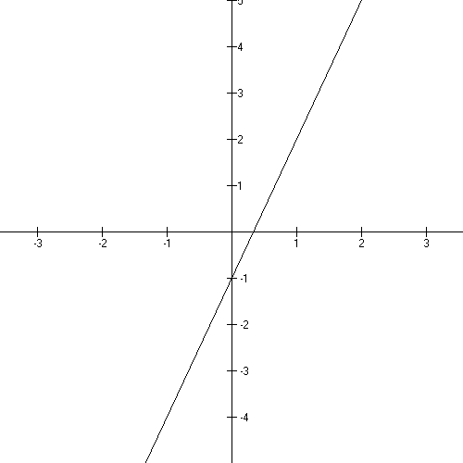

Note that the graph is a subset of the Cartesian Plane. We’ve graphed point pairs
(x, 3x − 1) for x any real number.

[for a review of interval notation, see the handout in the Functions folder on my website]

x-intercept and y-intercept

0
0

EXAMPLE 3: Restricted Domains and Ranges

Sometimes, it happens that some real numbers are not allowed in the calculation of point pairs – this creates domain restrictions. And sometimes, not every real number is calculated as a second coordinate which makes range restrictions. Sometimes, too, a problem comes with a restriction written right into the problem statement. Be alert for any of these situations!

3− A A naturally restricted range

$$f(x)=x^{2}+4x−5$$

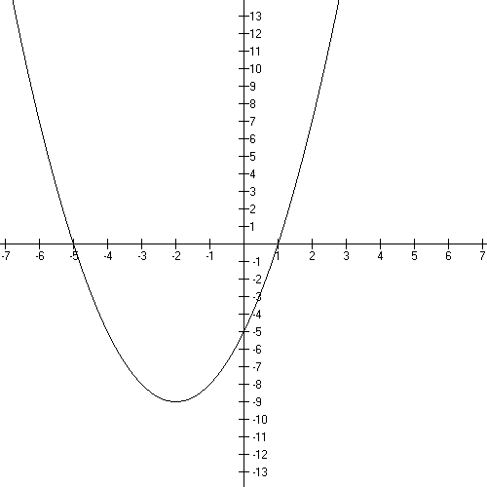
Domain: $(−∞,∞)$*
*the domain for every parabola is
unbounded.

Range: $[−9,∞)$**
**Show on graph!

You do not use every real number
on the y-axis as a second coordinate.
No matter which x you use,
you will get a y that is greater than
or equal to −9.

Note that the domain is unbounded and the range is
bounded below by −9.

Factoring: [see the handout on my website]

x-intercepts:

y-intercept:

Turn around point:* [Complete the Square: handout on my website]

$$f(x)=x^{2}+4x−5$$

*Called the vertex. Show on graph!

Can also be gotten by using $f(x)=x^{2}+4x−5$
Popper 02, Question 2

3 − B A restricted domain and range

$$f(x)=\sqrt{x−3}$$

Domain: $[3,∞)$
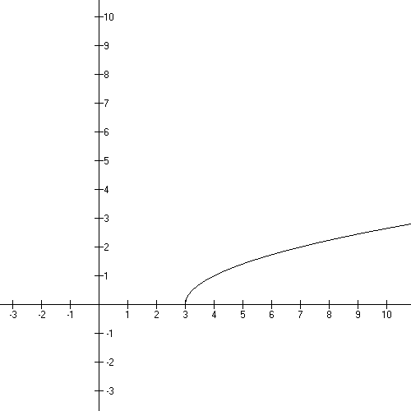
Range: $[0,∞)$

You cannot take the square root of a negative number and get a real number – you get a complex number, which doesn’t graph in the Cartesian Plane. So, since we’re interested in graphs, we say the domain is restricted to only those numbers that will produce a “graphable” y.

Note that you can see the domain and range of the function on the graph.

The domain is bounded below by 3 and the range is bounded below by 0.

3 − C A restricted domain and range

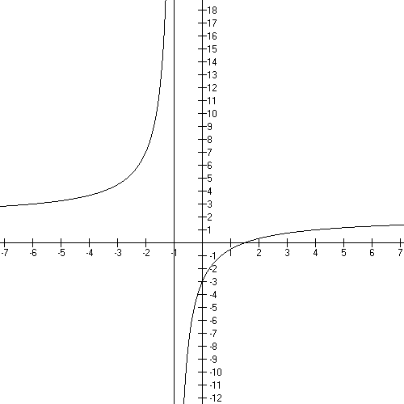
$$f(x)=\frac{2x−3}{x+1}$$

Domain: $(−∞,−1)∪(−1,∞)$

Range: $(−∞, 2)∪(2, ∞)$

Vertical Asymptote

Horizontal Asymptote

Note that the asymptotes are at the places missing in the domain and the range.

x intercept
(where y is zero)

y intercept
(x = 0)

Bounds!

We’ll be doing lots of these as the semester moves on. Don’t worry too much if you’re not remembering much about it. Just note the restricted domain and range, the discussion of bounds, and look over the calculations.

Popper 02, Question 3

How to find the domain:

The domain of a function is ALWAYS all real numbers, $(−∞,∞)$, unless the function has one of the following problems in the formula or problem statement:

- a square root (or any even root)
- a divide by an expression with an x
- a “log” as a function name
- a given restriction in the problem statement

We will use the graph to find the range unless the function is a very basic one.

Square roots* (n.b. *or any even root)

We all know you can’t take the square root of a negative number and get a real number; you get an imaginary number that you can’t graph in the Cartesian Plane.

So, if you’re working with point pairs and you’ve got an x that gives you an imaginary y, you throw that x out and say it’s “not in the domain”.

Doing this x by x takes too long. So we do it with algebra.

You can always take the square root of zero and any positive number.

So

- Take the expression under the radical, called the radicand
- Set it greater than or equal to zero
- Solve for x
- Report the solution in interval notation

EXAMPLE 1: What is the domain for $f(x)=\sqrt{2x+\text{12}}$ ?

- Take the expression under the radical: 2x + 12

- Set it greater than or equal to zero $2x+\text{12}≥0$

- Solve for x
Subtract 12 from both sides
Divide both sides by 2

- Report the solution in interval notation $[−6,∞)$

SQUARE BRACKET! “ “

This is the domain. So this domain is bounded below by −6.

Sketch this graph:

The x-intercept is
(where y = 0)

The y-intercept is
(f(0)=)

EXAMPLE 2: What is the domain for $f(x)=\sqrt{\text{15}−3x}$ ?

Take the radicand: 15 − 3x.

Solve for x

(remembering that to multiply or divide an inequality by a negative induces a symbol reversal!)

$$\begin{aligned}\text{15}−3x≥0 \\ −3x≥−\text{15} \\ x≤5 \\ (−∞,5]\end{aligned}$$

This is the domain and it is bounded above by 5. Square bracket!

Sketch the graph:

x-intercept:
(where y = 0)

y-intercept:
(f(0) = )

A recap on the process:

- Take the expression under the radical, the radicand.
- Set it greater than or equal to zero
- Solve for x
- Report the solution in interval notation

Popper 02, Question 4

Divides with an expression that contains an x

note that dividing by a number, like 3, is not a domain problem
the domain for $f(x)=\frac{2x^{2}+1}{5}$ is all real numbers (i.e. unbounded).

We also know you can’t divide by zero. So

- Take the expression in the denominator
- Set it equal to zero
- Solve for x
- Throw those x’s out out, off the number line
- Report THE REST as the domain

EXAMPLE 3: Find the domain for $f(x)=\frac{x^{2}−1}{x^{2}+5x+6}$

- Take the expression in the denominator
- Set it equal to zero $x^{2}+5x+6=0$

- Solve for x $\begin{aligned}(x+2)(x+3)=0 \\ x=−2 \text{or} x=−3\end{aligned}$

- Throw them out, off the number line

−3
−2

- Report THE REST as the domain

$$(−∞,−2)∪(−2,−3)∪(−3,∞)$$

Look at all those boundaries!

EXAMPLE 4: Find the domain for $f(x)=\frac{4}{x^{2}−9}$

Take the expression in the denominator. Set it equal to zero and solve for x.

$\begin{aligned}x^{2}−9=0 \\ (x+3)(x−3)=0 \\ x=−3 \text{or} x=3\end{aligned}$

Throw those x’s out of the numberline.

−3
3

Report the rest as the domain:

$(−∞,−3)∪(−3, 3)∪(3,∞)$ this is the domain.

Notice how this interval notation fits exactly on the number line!

There will be vertical asymptotes right here at these domain restrictions when you graph this!

Note that you need to be good at factoring for this. For practice, see the handout on my website!

A recap on this:

- Take the expression in the denominator
- Set it equal to zero
- Solve for x
- Throw those x’s out out, off the number line
- Report THE REST as the domain

Popper 02, Question 5

Logarithms:

All logarithm functions have a restricted domain. Logarithms are all labeled “log, base b” clearly so you’ll know when you’ve got one. Here’s the procedure:

- Take the argument
- Set it greater than zero. Solve for x.
- Report these x’s as the domain.

EXAMPLE 5:

What’s the domain for $f(x)={\text{log}}_{9}(x+5)$?

$$\begin{aligned}x+5>0 \\ x>−5\end{aligned}$$

So the domain is (−5, $∞)$.

EXAMPLE 6:

What’s the domain for $f(x)={\text{log}}_{2}(6−x)$?

$$\begin{aligned}6−x>0 \\ −x>−6 \\ x<6\end{aligned}$$

The domain is ($−∞$, 6)

A stated restriction in the problem statement must be copied and followed.

Popper 02, Question 6

Tell me the domains for the following!

Popper 02, Question 7

Tell me the domains for

Popper 02, Question 8

Tell me the domains for:

Popper 02, Question 9

Popper 02, Question 10

End Video 2.

Evaluation

This is an excursion through minus signs, fractions, and exponents.

Given: f(x) = $x^{2}−x+2$
Evaluate: f(−1) = $(−1)^{2}−−1+2$= 4

So (−1, 4) is a graph point of the given function.

Replace each x with the indicated value and compute the y = f (x).

The domain is unbounded and the range is bounded because there’s a turnaround point at the vertex!

Notes:

remember:

x = 5

x = ½

x = −2

x = 0

remember:

remember: a fractional exponent is “root-finding”

Putting it all together:

Popper 03, Question 1

EXAMPLE 1:

What is the domain for this function?

Calculate f(0) =

Calculate

Calculate

Calculate

Popper 03, Question 2

EXAMPLE 2:
What is the domain for this rational function?

Calculate
f(−1)

f(0)

f(1/2)

f(2)

Popper 03, Question 3

EXAMPLE 3:
What are the domain and range for this graph?

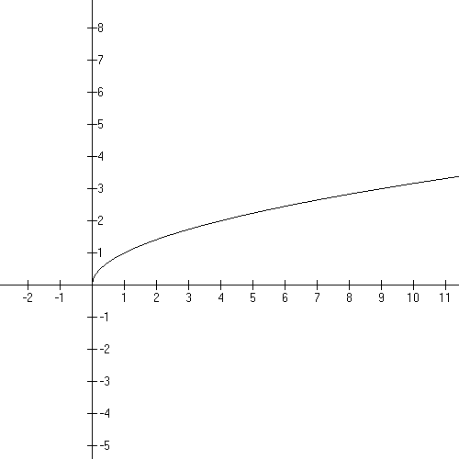

Calculate:

f (0)

f (4)

f (2)

f()

EXAMPLE 4:
Given two points, let’s review how to get the formula for the line they determine.
The Point-Slope Formula is the way to go:
where m is the slope:
I always use a box to get the slope – it helps keep things organized.
Suppose we have (−1, 3) and (−3, −3) as our points:

−1 | 3
−3 | −3

Now subtract down the columns and stack appropriately:

Now use the Point-Slope formula

Substitute into our formula using the first point:

This y is an f(x).

What are the domain, range, and graph of this function?

Popper 03, Question 4

EXAMPLE 5:

exponential function

Graph:
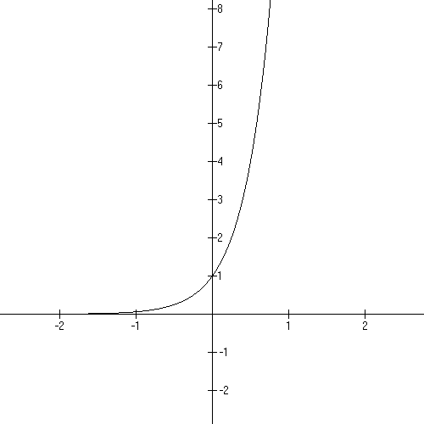
Domain:

Range:

Leftward asymptotic to the
x-axis

Evaluation:

f (−1) =

f (0) =

f (1/2) =

=

Popper 03, Question 5

Intercepts and asymptotes

Many graphs have intercepts and asymptotes.

The y-intercept is always f (0). So it’s mostly an evaluation problem.
The x-intercept is found by setting y = f (x) = 0 and solving for x.

Asymptotes:

Horizontal: Lines and parabolas, polynomials have none.
Exponential functions have a half-HA
some Rational Functions have one.

If you have a rational function, divide the power of the numerator by the power of the denominator:
greater than one: no HA
less than one: HA is the x axis
equal to one: HA is the ratio of the leading coefficients.

Vertical asymptotes: at the domain restrictions, always.

EXERCISE 1:

Find the domain, x-intercept(s) and y-intercept for the following functions:

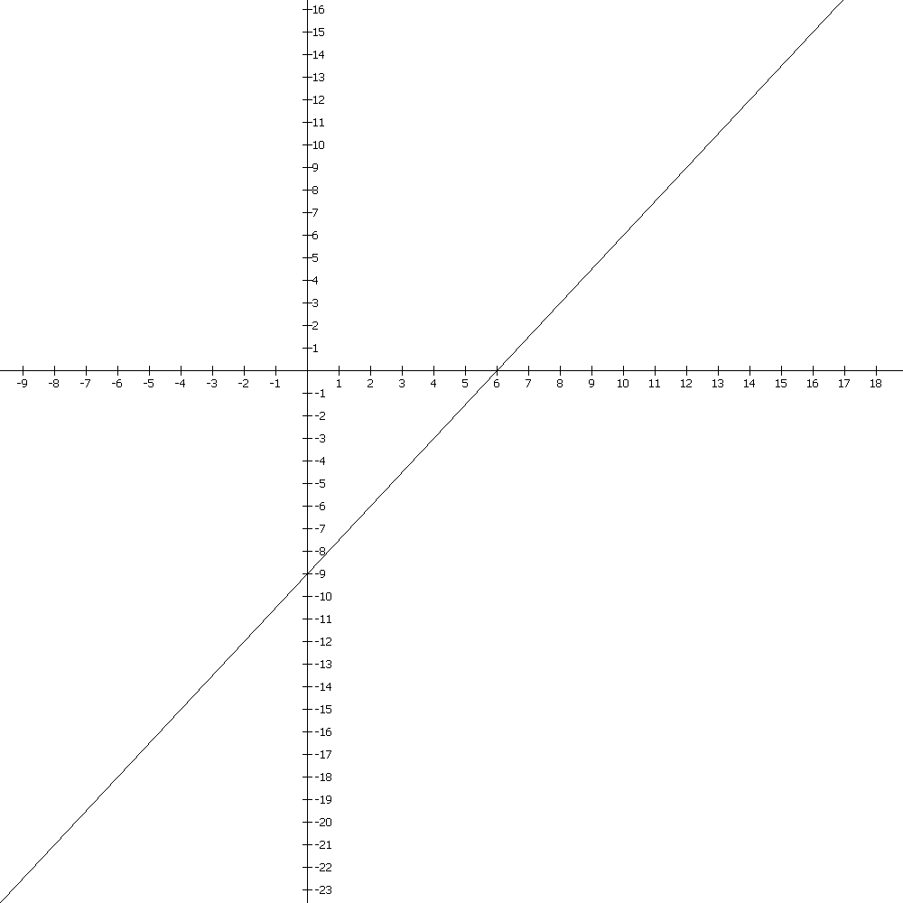
a line:

Domain:

Intercepts:

Any asymptotes?

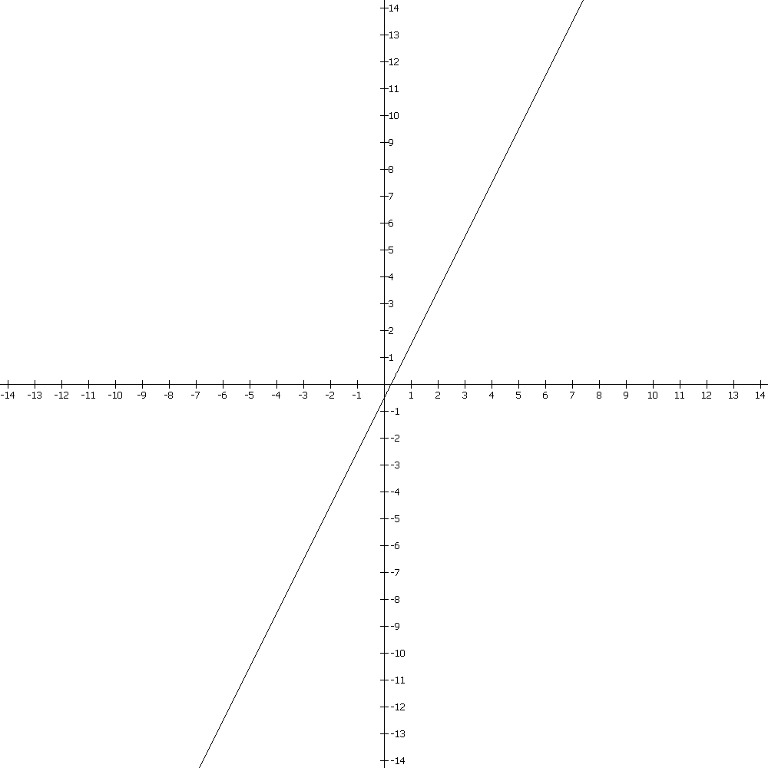
another line:

Domain

Intercepts:

Any asymptotes?

A parabola:

Domain:

Intercepts:

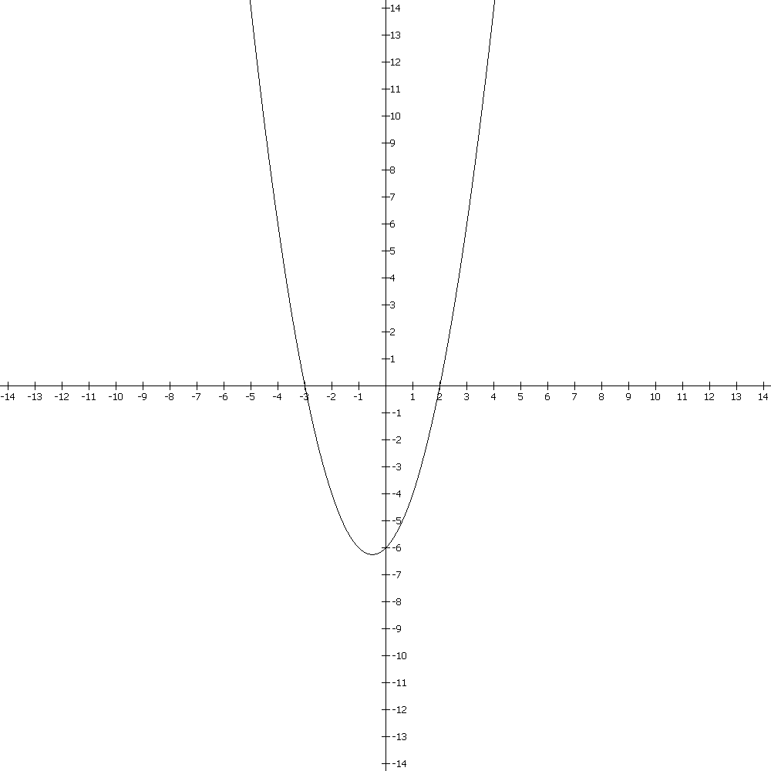

Any asymptotes?

A polynomial:

Domain :

Intercepts:

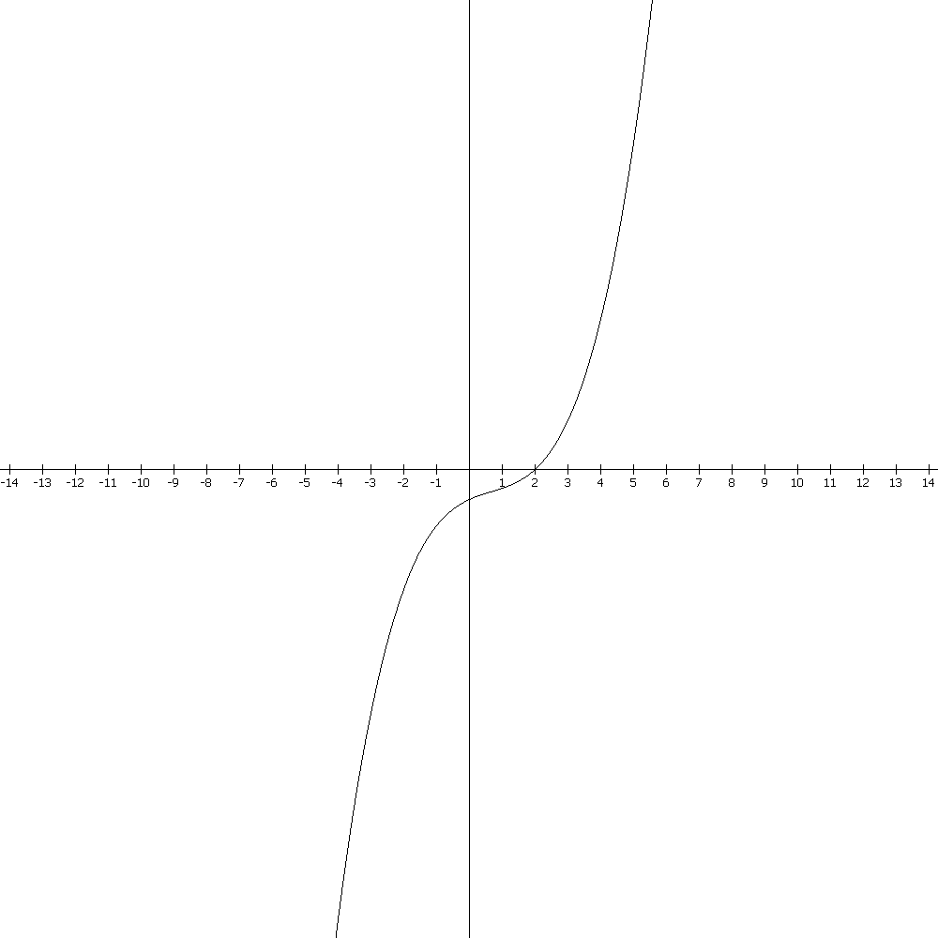

Any asymptotes?

A rational function:

Domain: See that restriction?
That’s a BIG HINT!

Vertical Asymptote:
Is at the x that zeros out the denominator, so it’s the opposite sign from what is in the expression.

Horizontal Asymptote:
If you have a rational function, divide the power of the numerator by the power of the denominator:
greater than one: no HA
less than one: HA is the x axis
equal to one: HA is the ratio of the leading coefficients.

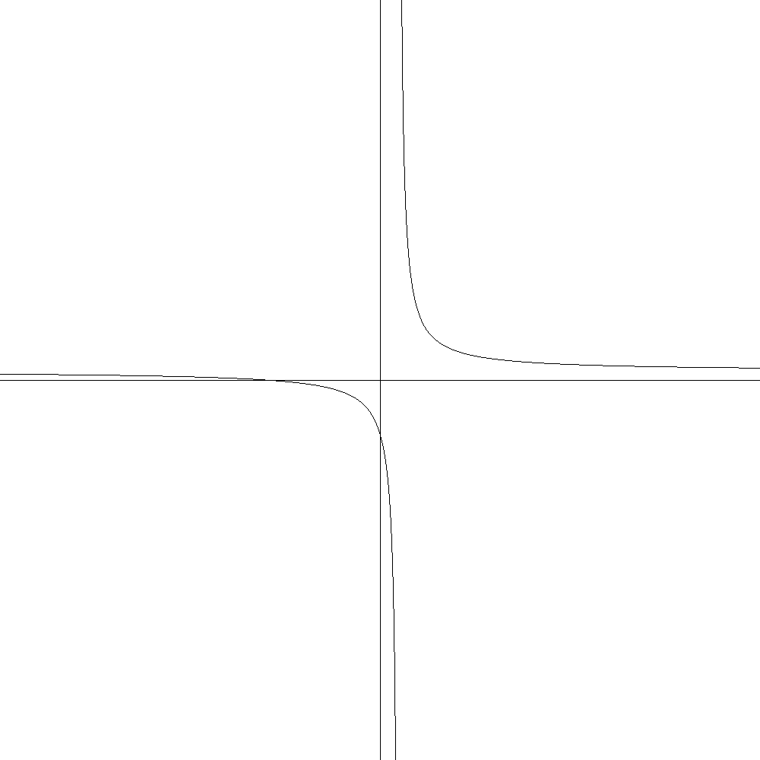

Intercepts:

Another rational function:

Domain: CLUE!

Vertical asymptote – not quite. A hole in the graph because of the canceling!

Horizontal asymptote:
If you have a rational function, divide the power of the numerator by the power of the denominator:
greater than one: no HA
less than one: HA is the x axis
equal to one: HA is the ratio of the leading coefficients.

Graph
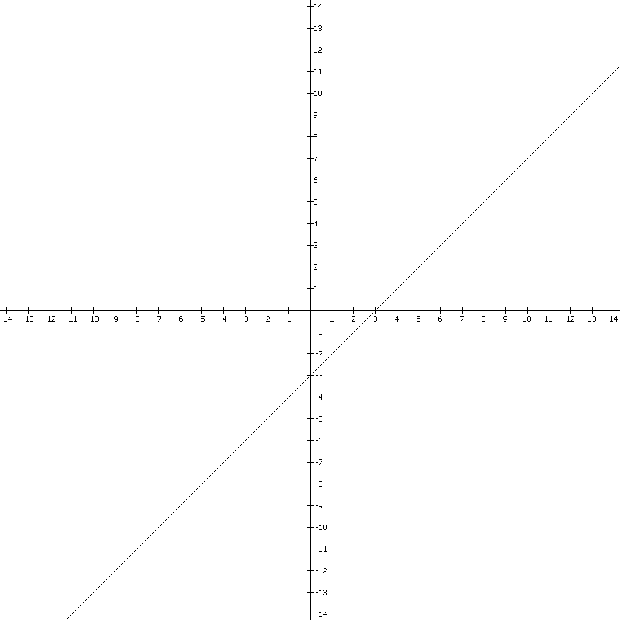

Intercepts:

Yet another rational function:

Domain:

Vertical asymptotes or holes:

Horizontal asymptote:
If you have a rational function, divide the power of the numerator by the power of the denominator:
greater than one: no HA
less than one: HA is the x axis
equal to one: HA is the ratio of the leading coefficients.

Add the asymptotes and holes:

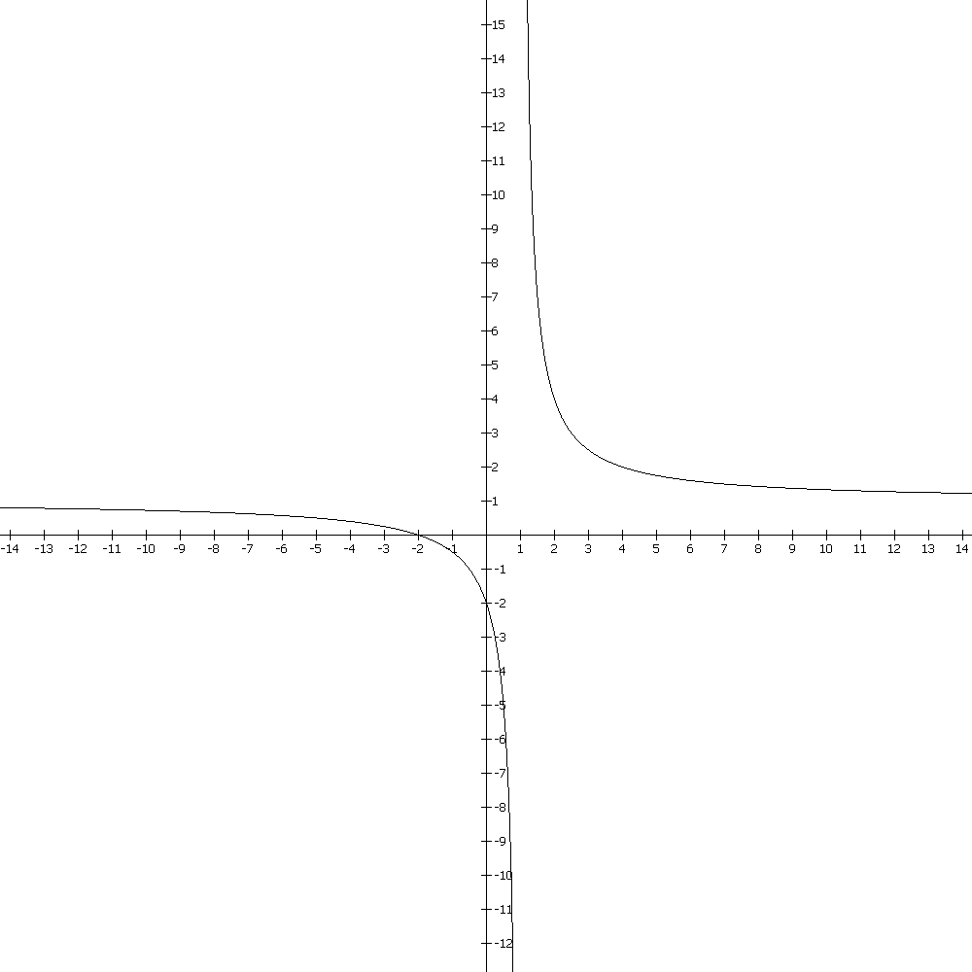
Intercepts:

Popper 03, Question 6

an exponential function:

Domain:

Intercepts:

Any asymptotes?

YES! A half asymptote at y = −25, going in the negative direction!

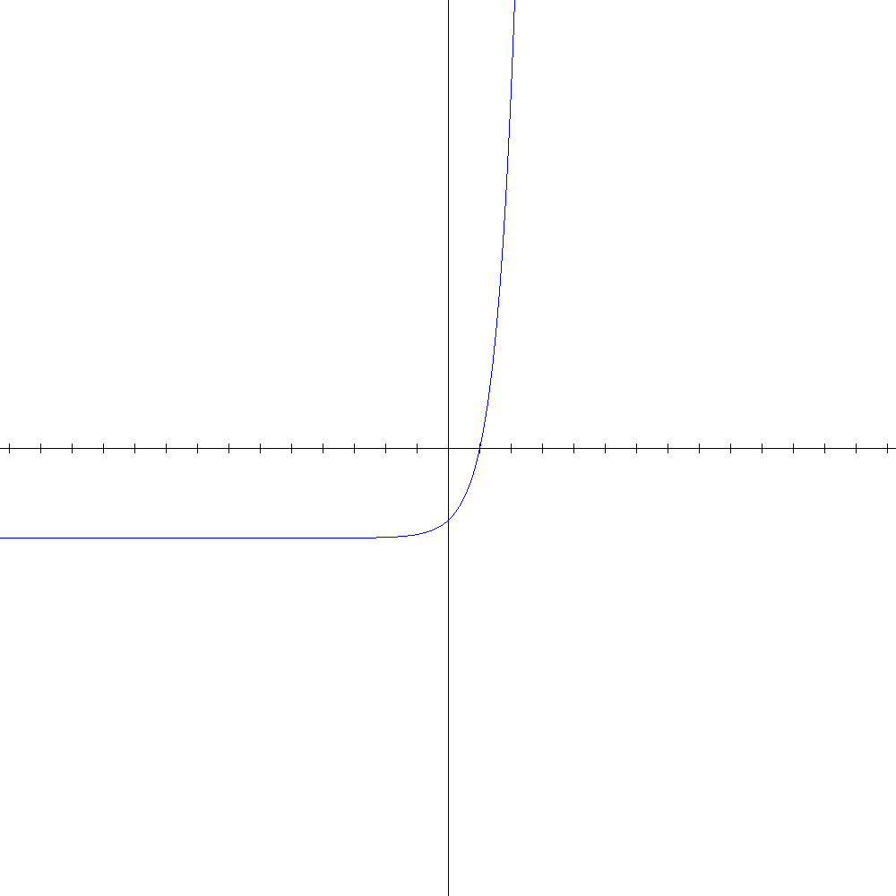

Another exponential function:

Domain:

Intercepts:

Any asymptotes?
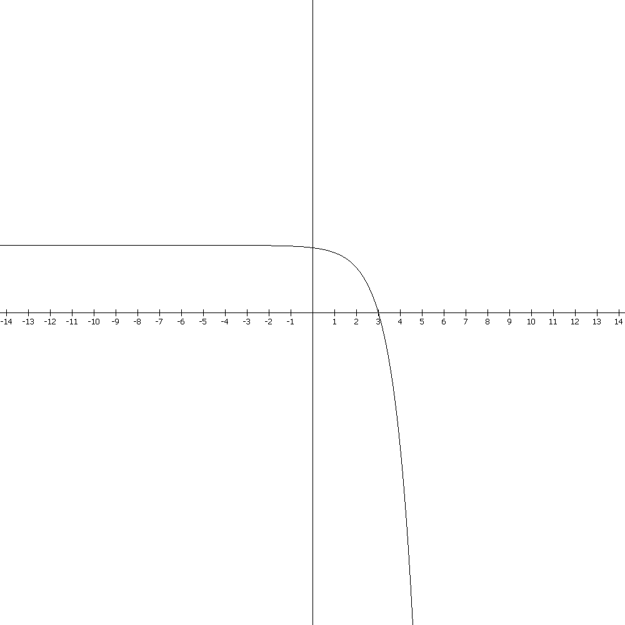

Popper 03, Question 7

Polynomials

A polynomial in x has one or more terms with a real number coefficient and a whole number exponent.

EXAMPLES:

$f(x)$= 3 = $3x^{0}$

$$f(x)=x^{2}+5x+4=x^{2}+5x+4x^{0}=(x+4)(x+1)$$

$$f(x)=x^{3}−1=(x−1)(x^{2}+x+1)$$

$f(x)=−x^{7}−\text{49}x=−x^{7}−\text{49}x+0x^{0}$

The domain for every polynomial is all Real numbers. Always. And they never have any asymptotes. You’ll have to get the range by graphing the function and looking at the graph.

The y-intercept is f(0) as always.
To get the x-intercept(s), set y = f(x) = 0 and solve for x.

Let’s look at some functions that are NOT polynomials:

Popper 07, Question 8

Tell me everything about f(x) =

Domain

Vertex

Range

x-intercepts

y-intercept

Evaluate f(1/3)

Sketch the graph

Any asymptotes?

Popper 03, Question 9

Find the domain, intercepts, and range for

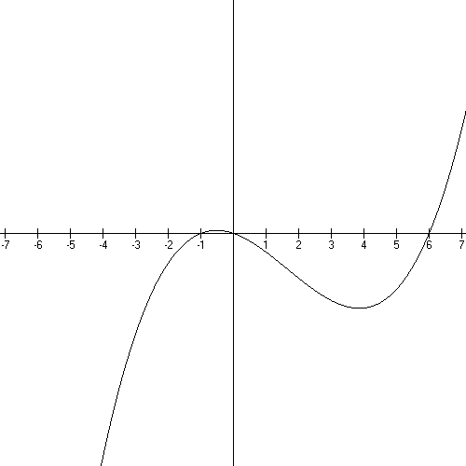

The graphs in this section are from a free program called MathGV. It’s easy to use.

Popper 03, Question 10

End Video 3

End Basics

Additional Resources

My website:

www.math.uh.edu/~dog

Worksheets under “3304/Basics”

Interval Notation
Factoring
Complete the Square

Math 1330 etext website:

www.online.math.uh.edu

Math 1330, streaming videos:

Prerequisite Information
Ch. 2
Ch. 3

